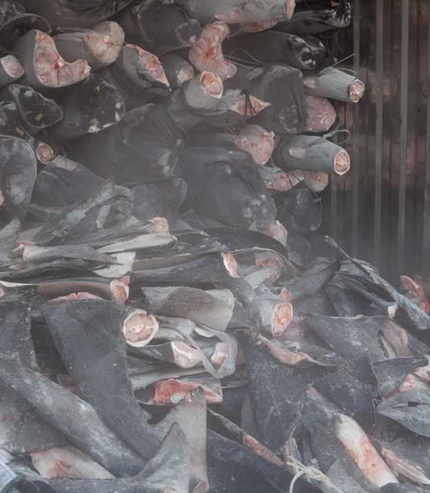

PRESS KIT

stop-finning.eu

FebruarY 2021

#StopFinningEU
It´s time for Europe to act!

CONTENT

#StopFinningEU It´s time for Europe to act! 1
CONTENT 2
PRESS INFORMATION 3
FACTSHEET 4
INITIATORS 5
THE EUROPEAN CITIZENS' INITIATIVE PROCEDURE 6
DOWNLOADS & INFORMATION 7

PRESS INFORMATION

The trade in shark fins in Europe must end immediately!

Every year, between 63 and 273 million sharks die as a result of human activity. The exact numbers remain speculation, as there is a lack of reliable data and the worldwide number of unreported cases of illegal fishing is extremely high. Sharks are hunted worldwide, primarily because of their fins. These are eaten especially in the Asian region as shark fin soup. For this supposed delicacy, with a few grams of fins, up to 90€ are required. A lucrative business with huge profit margins at the expense of the sharks!

The fins are often caught in a cruel way by “finning”. Finning means that the sharks’ fins are cut off alive. The animals are then thrown overboard because their meat is almost worthless compared to the fins. Without fins the sharks sink to the seabed where they suffocate, bleed to death or are eaten alive.

Although since 2013 the "Fins Naturally Attached" regulation of the European Union prohibits without exception the storage, transhipment and landing of all shark fins in EU territorial waters and on all EU vessels, the EU is one of the largest exporters of fins and a major transit hub for the global trade of fins. The EU is a major player in shark fisheries and, because there are few inspections at sea, fins continue to be illegally retained, transhipped or landed in the EU.

The citizens' initiative "Stop Finning – Stop the Trade" aims to end the trade in fins in the EU, including the import, export and transit of fins that are not naturally present on the body of the animal. As the removal of fins ("finning") prevents effective conservation measures for sharks, the citizens' initiative requests that Regulation (EU) No 605/2013 be extended to trade in fins and therefore calls on the Commission to draft a new regulation extending the criterion of "fins naturally present on the body" to all trade in sharks and rays in the EU.

Additionally, to the citizen’s initiative a charitable association was founded – StopFinningEU e.V.

FACTSHEET
Citizen’s initiative Association

Founding year: 2019 2020

Name: Stop Finning – Stop the Trade StopFinningEU e.V.

Legal structure: European Citizens' Initiative Charitable association

Representative: Spokespersons Board
Nils Kluger Nils Kluger (chairman)
Alexander Hendrik Cornelissen Christian Hempel
(substitute) Karen Reinhardt

Member: 13 further members from the European countries

Luis Miguel Fonseca Alves | Veerle Gishlain Roelandt
Portugal | Italy
Katrien Vandevelde | Chrysoula Gkoumpili
Belgium | Greece
Monica Gabell | Sabine Reinstaller
Sweden | Austria
Fernando Frias Reis | Fabienne Rossier
Spain | France
Frédéric Xavier Le Manach | Alexandar Dourtchev
France | Romania
Julian Engel | Andrew Mark Griffiths
United Kingdom | United Kingdom

Objective: The aim of the initiative is to end the trade of fins in the EU, including the import, export and transit of fins that are not naturally attached to the body of the animal.

Press contact: Nils Kluger, media@stop-finning.eu

INITIATORS
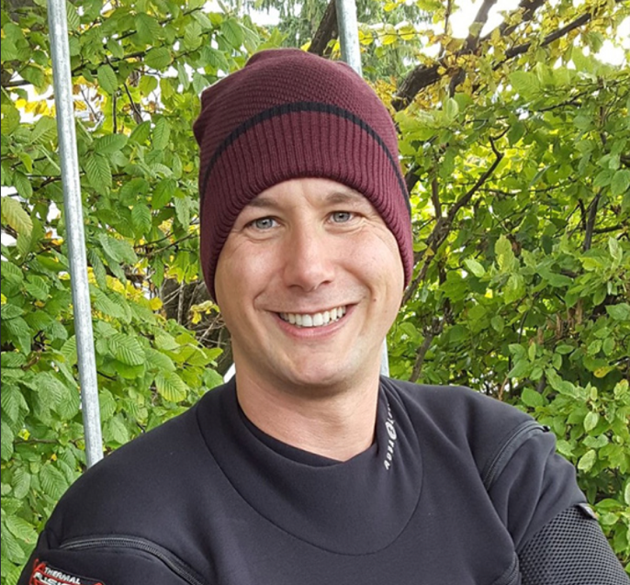
„With this initiative we as citizens have the chance to speak out against illegal finning and catching of sharks purely for their fins. The trading of fins from Europe must stop!”

Nils is a shark conservation activist and scuba diving instructor. He has been diving with sharks around the world and experienced both their beauty and meaning for marine ecosystems as well as the threats humans pose to their existence. Nils is working for Sharkproject, an international initiative for shark conservation.

Nils Kluger, Spokesperson

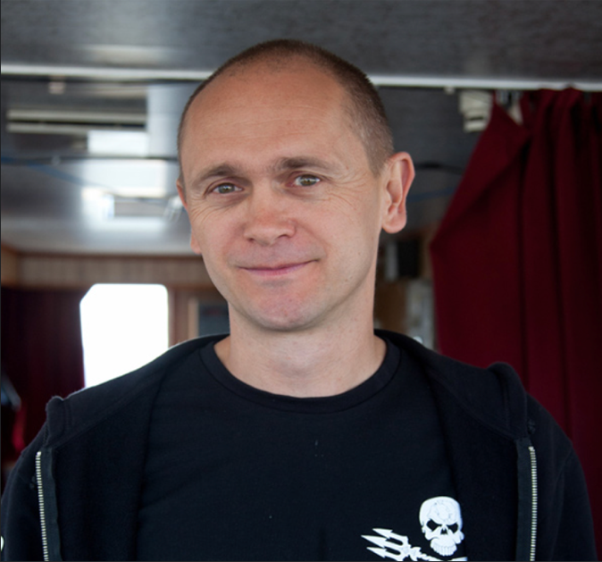
„Sharks are the most underappreciated animals in the oceans, sheer perfection and beauty. The importance of sharks in the eco-system is fundamental in the survival of the oceans; we need to step up our measures to protect sharks.”

Alex is the CEO of Sea Shepherd Global. Through his work for Sea Shepherd he has witnessed first-hand the devastating effects of shark fishing on shark populations worldwide. He has also had the privilege to dive with sharks in many remote areas.

Alex Cornelissen, Substitute Spokesperson

THE EUROPEAN CITIZENS' INITIATIVE PROCEDURE

To be validated, a European Citizen’s Initiative must gather at least one million signatories overall and reach a threshold for at least seven Member States. The minimum number required is about 750 times the number of members of the European Parliament in that state - in Germany, for example, the number of signatures is 72,000.

Member State | Threshold
Germany | 72 000
France | 55 500
Italy | 54 750
Spain | 40 500
Poland | 38 250
Romania | 24 000
Netherlands | 19 500
Belgium | 15 750
Czech Republic | 15 750
Greece | 15 750
Hungary | 15 750
Portugal | 15 750
Sweden | 15 000
Austria | 13 500
Bulgaria | 12 750
Denmark | 9 750
Slovakia | 9 750
Finland | 9 750
Ireland | 8 250
Croatia | 8 250
Lithuania | 8 250
Latvia | 6 000
Slovenia | 6 000
Estonia | 4 500
Cyprus | 4 500
Luxembourg | 4 500

DOWNLOADS & INFORMATION

EU Citizens' Initiative: https://eci.ec.europa.eu/012/public

General information about the EU Citizens' Initiative: https://eci.ec.europa.eu/012/public/#/screen/home

Stop-Finning

Website: stop-finning.eu

Facebook: https://www.facebook.com/StopFinningEU

Instagram: https://www.instagram.com/stopfinningeu

Twitter: https://twitter.com/stopfinningeu

Download Press releases & Media: https://www.stop-finning-eu.org/presse

Download Leaflets & Offline Collection: https://www.stop-finning-eu.org/download

Supporter: https://www.stop-finning-eu.org/supporter

IUCN Shark Specialist Group, Frequently Asked Questions: Sharks, Rays, and chimaeras; https://www.iucnssg.org/faqs.html.
Kimley, Peter A. Peter, The Biology of Sharks and Rays, 2013, S. 451.
https://eur-lex.europa.eu/legal-content/DE/TXT/?uri=CELEX:32013R0605

